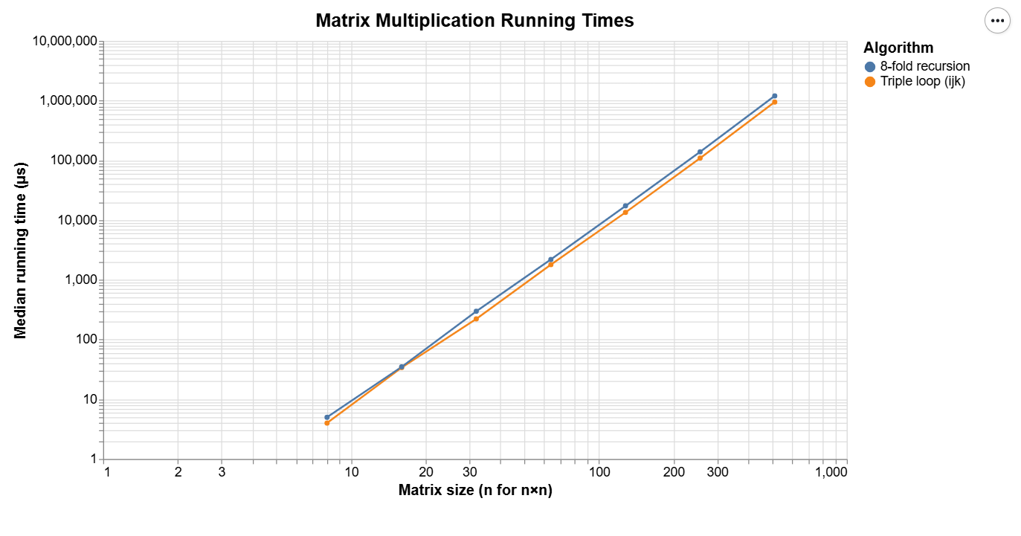
The triple loop algorithm takes n x n x n time to iterate through the 3 loops for ijk which brings it to f(n) = n^3.
The 8-fold recursion does 8 calls of n/2 size which gives 8T(n/2), and when adding the overhead that occurs for calling functions, the time comes to f(n) = 8T(n/2) + theta(1);
This can be seen by how the growth rate of the 2 function remains relatively constant to each other.

